**Matebook X Pro BIOS Upgrade Guide**

1. Before you update BIOS, please refer to this document for details when your system needs a BIOS update. Reminds you of the following:

(1) The remaining power of the machine to be upgraded to ensure that the electric quantity is greater than 30% .

(2) Plug in charger.

(3) Check system BIOS version is older than BIOS update package version.

Check the BIOS version：Press **Windows**+**R** on the keyboard. Enter **msinfo32** in the box that pops up to view your BIOS version, as shown in the following figure.

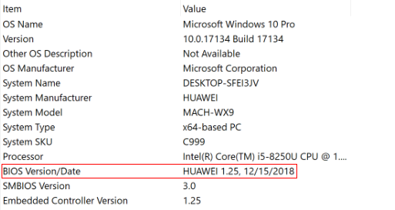

1. When system meet above condition. Double-click the **ARIWU115.exe** file. A dialog box will pop out due to the designed Windows 10 security mechanism, Click **Yes** to proceed.



1. Then the system will pop-up below dialog box, and click on the “**OK**” button .

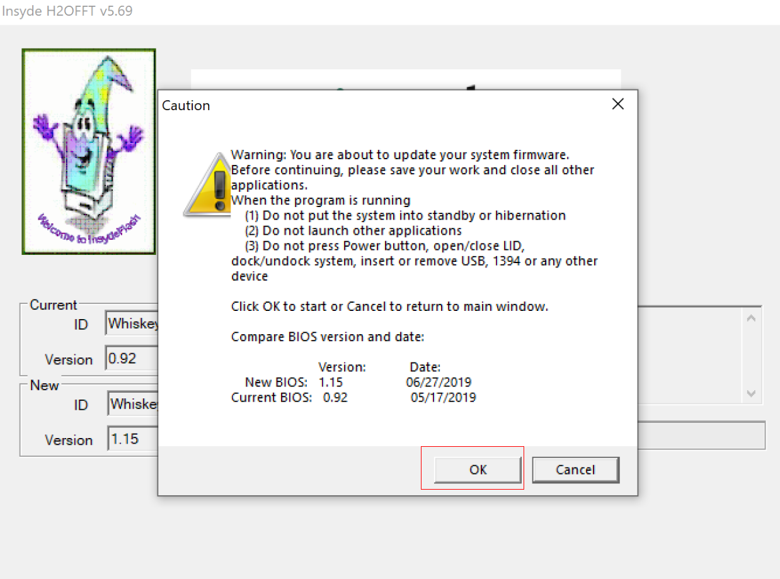

1. System will automatic restart, then start to flash, after flash BIOS, System will automatic restart to desktop.
2. The normal process as below.

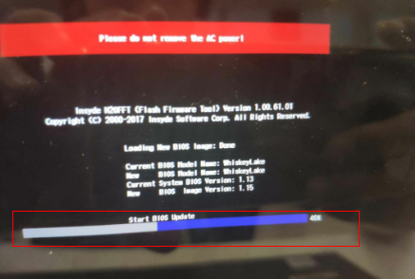

(2) If Battery capacity Battery Capacity is lower than 30%.

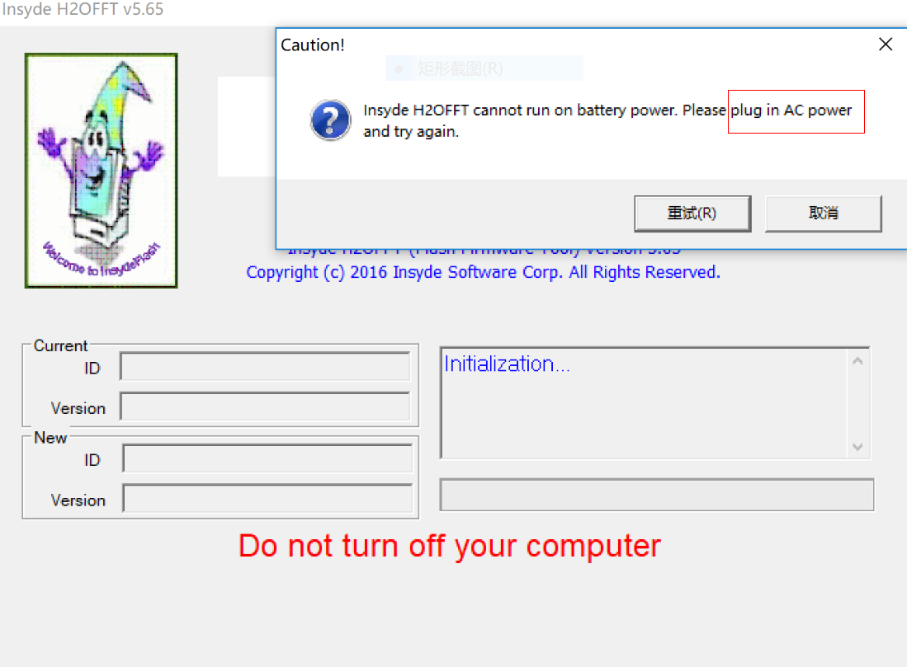

(3) If system BIOS version is same as BIOS update package version.

